CHAPTER 2: Europe’s High Middle Ages (1000-1300)
Part 3 Name:

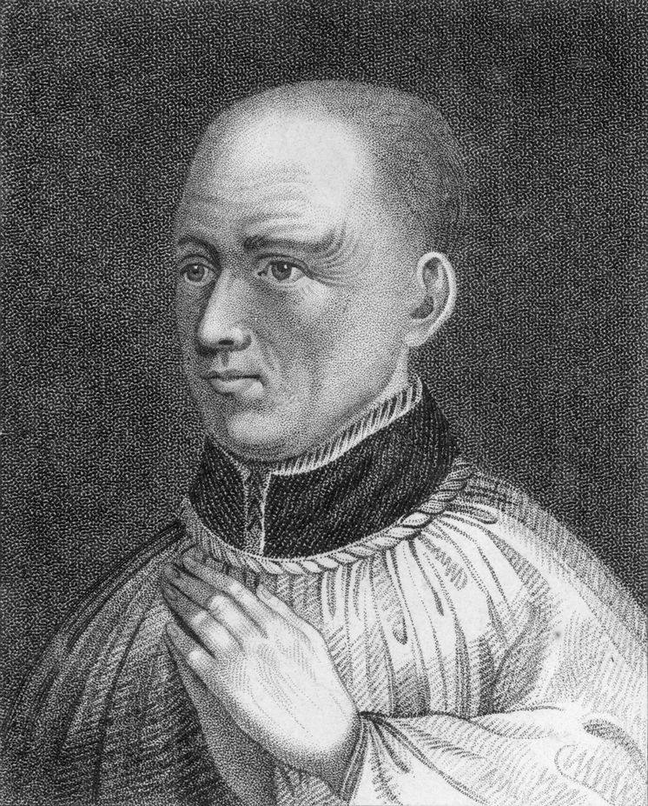
Henry II and Thomas Becket
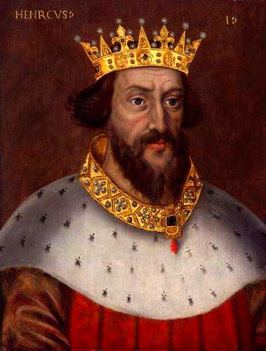
- Henry II despised Thomas Becket, the archbishop of Canterbury, because of his _________ against the King
- King took his ______ and exiled Thomas
- Thomas returned __ years later and continued to ________ the King
- King complained to his knights who took it upon themselves to _____ Thomas
- Pope Alexander III forced the King to submit to a public _____ and then canonized (to declare a saint) Thomas making him the most popular saint in England
- Canterbury Cathedral became the country’s greatest shrine

World View
- Most medieval Europeans were ___________ and had no idea of the world beyond their boundaries
- Travelling was dangerous due to outlaws, usually had to travel with a __________
- Nobles travelled often to visit relatives, for war, and to trade but knew little about the _________
- Maps were rare and placed Jerusalem at the centre (Why?)
______________________________________________________________________________________________________________________________________

Check your Understanding #4
- 1) What were trials by ordeal and trials by battle? How was a person’s guilt decided? Was this a good method?
- 2) What are the 3 types of court? Which types of crime do each of them handle? Which is the most lenient?
- 3) What is common law?
- 4) Why did nobles have a better understanding of the outside world than serfs?
- 5) How could you gain information about the outside world during medieval times? How did that support tall tales?

The Crusades
- The Crusades were wars fought between Christians and ________ for control of the Holy Land (Jerusalem, modern-day Israel)
- Is holy because it is _____ lived and died there but the Muslim prophet ______ also rose to heaven from this location
- Muslims feel that they will also rise to ________ in Jerusalem
- There were ___ different crusades that took place between 1096-1254 with different groups taking control at various times
- The Muslim leader Sultan Saladin finally brought an end to the Crusades by establishing a ________ Muslim army
- An indirect positive is the Crusades was an exchange of information including: math, medicine, philosophy, and literature, amongst Muslims, Jews, and Christians
- Eventually led to a __________ in Europe and increased trade borders to new fruits, spices, and silk
- Boosted the European __________

Royal Power and Democracy
- Medieval people had to concept of a ____________
- Monarch (King or Queen) ruled and had ________ to make laws, collect taxes, give titles/estates, etc.
- Monarchy did ______ have unlimited power
- They still had to remain within the feudal system so were limited by other wealthy nobles (barons) and the Church
- Since Barons had large ________ they were a threat
- Monarch had to be careful to not _________ them

Eleanor of Aquitaine
- Lived a legendary life
- Married Louis VII of France
- Believed in gender _________ so she dressed in knightly armour during battles
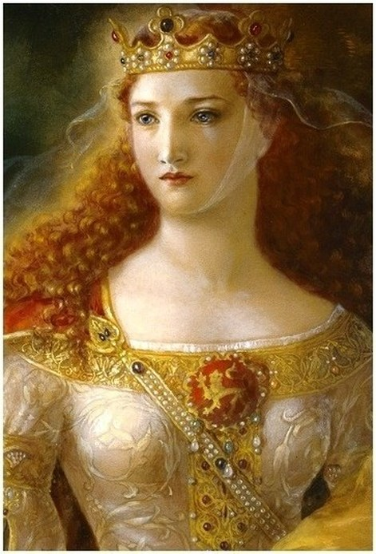
- Louis VII ended the marriage and she then married his greatest rival, Henry II, the King of ___________
- She had ___ children with Henry but he would not ________ his power
- She then encouraged her sons to _______ against him
- Henry found out and threw her in ________
- She was released after Henry’s ______ and helped her son, King John I, rule

King John I
- Known as the villain from the legend of ________ ________
- Fought with the ______ and was excommunicated
- Pope placed all of _________ under an interdict (restricted everyone from all church ceremonies)
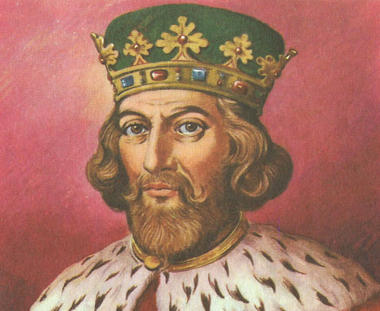
- Later gave the pope control of all English lands and ________ everyone in the kingdom to give to the Church
- Also regularly broke the _______ code
- 1214, the ________ rebelled

Magna Carta
- Barons eventually forced John to sign a charter called “Magna Carta” which guaranteed he would ________ the people of England
- Promised:
  - Taxes could not be taken without the consent of parliament
  - No person could be arrested without a proper trial
  - He would not prey upon his own people
- These rights now exist in ______ and was a big step towards democracy in _______

Check your Understanding #5
- 1) Why did so many armies participate in the Crusades? How did Saladin finally retain control?
- 2) Why were barons a threat to the King?
- 3) How was Eleanor of Aquitaine ahead of her time?
- 4) What was Magna Carta? Why is important in Canada today?

Vocabulary
- Imminent, alienated, tall tale, interdict

