CHAPTER 2: Europe’s High Middle Ages (1000-1300)
Part 1 Name:
The Feudal System
- In the early 11th century, England inherited a new social system based on land, loyalty, and religion (called feudalism)
- Centre of feudal life was the manor (self-sufficient community)
- People either worked the land or were landowners
- Church played a big role in people’s lives
- Had a legal system
- Similar to a military arrangement
- Main purpose was to support the lord of the manor who was generally a knight

William the Conqueror
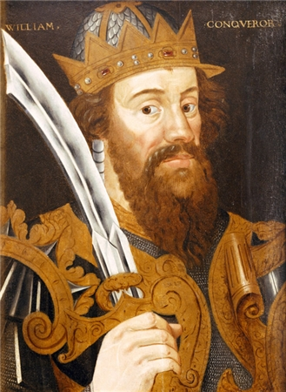
- From Normandy and won the Battle of Hastings
- Took possession of England and implemented the feudal system from Normandy
- Took lands from British nobles (earls) and gave them to his Knights
- In the old English system, people lived freely and opposed William’s changes
- William brutally ensured that feudalism would be established and it was throughout England within 5 years

The Feudal Contract
- Based on the 3 F’s: fief (land), fealty (loyalty), and faith (religion)
- Land was the source of all wealth
- Land was given to Knights in exchange for loyalty and was bound by an oath
- Knights (new nobles) had __ obligations
  - Had to serve in the army at least 40 days per year
  - Had to supply the King with additional Knights during war
  - Had to serve in court and give the King advice
  - Had to give the King money on special occasions (weddings, etc.)
- In return, nobles had the King’s _________ from attacks and help in settling disputes with other nobles
- Relationship was cemented by a ceremony involving an _____ and allegiance (loyalty)
- Nobles had similar ceremonies with _______ nobles (vassals)

The Feudal Hierarchy
- Land and protection were ___________ for loyalty and military support throughout the hierarchy
- These “contracts” kept the __________ and was the foundation of the feudal system
- Words to know:
  - Tenant: person who occupies land
  - Serf: farming labourer
  - Freeholder: person who owns land (but pays fee to the King)
  - Vassal: holder of land based on an allegiance
  - Lord of the manor: tenant of a noble, runs the manor for profit
- ________ gave nobles land (former Knights, also known as barons)
- They lived on their land and other nobles also lived on their land (called lords/tenants)
- Every noble had land (_______) and was the “lord of the manor”
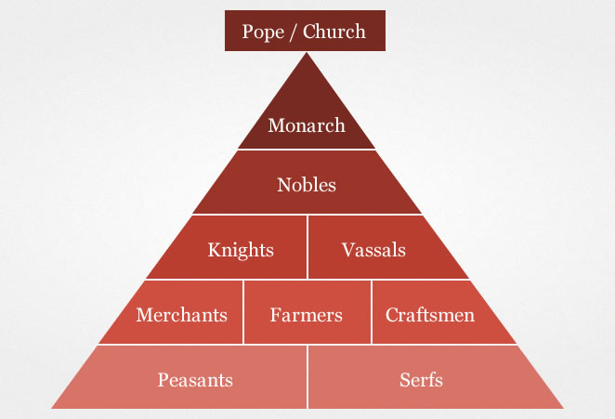

- Serfs and freeholders worked the land (___)% of the population) and had few ________ and power
- Serfs had no power and were considered a part of the __________ so could not be removed from it

Check your Understanding
- How did tenants gain protection? What did they offer in return?
- What is a contract? What is a feudal contract?
- What is the difference between a written and verbal contract?
- How did feudalism bring social order?
- How did feudalism suppress freedom? Who was exploited? What vital right did the exploited enjoy?
- Would you want this system in Canada?

Medieval Life and Custom
- Each _______ had farming lands, a pasture, a village, and woodlands
- The manor ___________ (usually close to water) had a mill, church, blacksmith’s shop, and a tannery
- Had skilled workers for most specific _______
- Lords also kept _________ (rent collector/supervisor)
- Homes were built from _______ and dirt floor
- Usually about _______ people lived in a house 9-10 metres by 3-4 metres with only one _____
- No plumbing or _____________
- Farm ________ lived in the home so conditions were unsanitary

Work and Cooperation
- Whole family helped with farming, even young __________
- Serf/freeholder children did not attend _________
- _______ had to cook for and cloth their families
- _______ spent majority of their time farming
- Grandparents were rare (Why?)
___________________________________________________________________
- Everyone worked from _______ to __________

Vocabulary
- Allegiance, Homage, Monumental, Contract, Freeholder, Exploit, Self-sufficient, Bailiff, Vermin, Vassal, Serf, Tenant

