CHAPTER 1: Europe’s Early Middle Ages
Part 2 Name:

The Franks
- After _____ fell, Germanic peoples moved into the territory
- Franks conquered much of it because they loved _____
- Most men walked around with a throwing ____ called a francisca
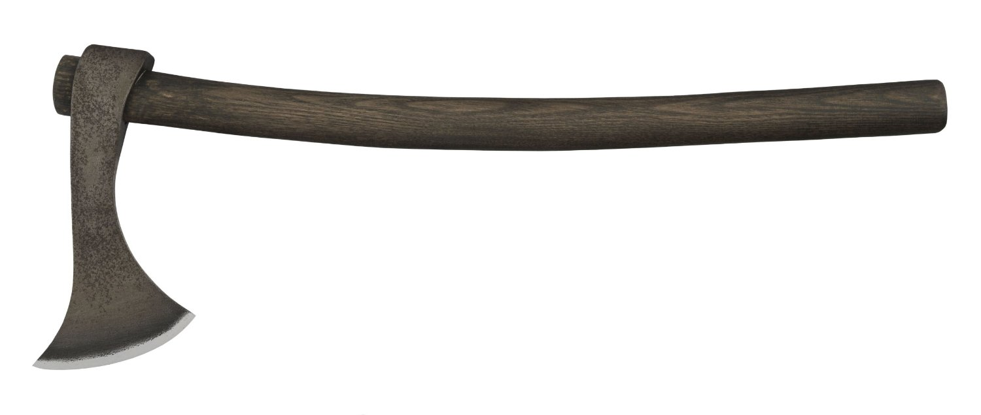
- Wore a lot of jewelry
- “Frank” meant ______

Frankish Law
- The Merovingian royal family ruled over the Franks and founded the country of France and made ________ the capital
- But in-fighting drove the kingdom into chaos
- Franks established their own _______ code (Salic Code)
- If property was stolen a _______ had to be paid
- In the case of murder, victim’s family could be paid or demand the guilty person’s _______
- If a relative of the victim carried out a revenge killing, was not ____________
- Also fined for cutting a person’s hair because it was used to determine one’s ____________

The murder of a women carried a lower fine than a man. Why do you think that was?

_________________________________________________________________________

_________________________________________________________________________

Charlemagne
- Came to power in 768 C.E. after his father made himself _______ by overthrowing the Merovingian rulers
- Charlemagne also known as Charles the Great
- Intelligent and _____________, unlike other Germanic rulers, he wanted to rebuild the civilization
- Governed his empire (Carolingian Empire) from Aachen (__________ today)
- Had a single code of laws for the __________ empire and ensured people were treated well
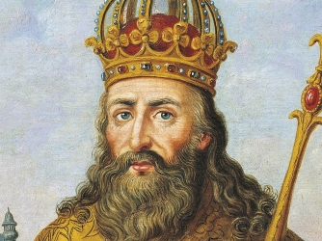
- Also was merciless when he ordered the killing of _________ defeated Saxons who refused to convert to Christianity

Charlemagne’s Renaissance
- Improved ____________
- Revived architecture and built ________ and churches
- This time is referred to the Carolingian Renaissance
  - Renaissance: rebirth (especially the arts)
- Died at 72 and ruled for ___ years
- Maintained peace and security which fell apart after his death

The Anglo-Saxons and The Celts
- Franks settled in Europe but _________ was controlled by the Anglo-Saxons after the Romans fell
- The Celts were pushed out to Wales and Scotland
  - Celts: western European culture
  - Their language and culture largely disappeared
- Anglo-Saxons were mainly ___________ and skilled metal workers
- England prospered but suffered from endless _________ raids much like the Franks
  - Prosperous: thriving, plentiful
Role of the Irish
- The Celts lived a brutal life until the 5th century
- St. Patrick became the patron saint of ___________ and brought Christianity and education
- Large communities were established which became home for monks and scholars fleeing the Germanic __________
- Up until Charlemagne’s Renaissance, Ireland was the ______ for learning in Europe
- Irish monks traveled all over _________ spreading knowledge and Christianity
- Also helped keep ancient cultures alive such as ________ and Greek classics

The Vikings
- In the late 8th century, the Vikings begin to ______ regions all over Europe
- They came from the ________ (Norway and Denmark today) looking to plunder
- Travelled in longships which allowed them to strike without __________
- Would disappear before a ________ could be assembled to stop them

Viking Reputation
- Were infamously destructive
- Common practice was to kill or enslave every man, _________, and ________ they encountered
- Led such cruel attacks that people thought they were soldiers of ______ sent to punish the world
- Many monarchs in England ________ the Vikings to stay away
- _____________ was one of the few leaders that defended his lands against Vikings

Everyday Vikings
- Biased view of Vikings because history is told from an ____________ point of view
- Many Vikings were _________ and farmers
- They most likely began raiding because modern-day Scandinavian (Sweden, Norway, Denmark) ____________ could not support the population
- Men and women shared responsibilities
  - ___________ could own property, divorce, and sue in court
- Viking landowners kept slaves whom had no _________
- Slaves were taken during raids or those who could not pay fines/________
- Despite Viking reputation as “barbarians”, they had a ______ culture and were skilled woodworkers
- Viking art shows gods such as Odin, _______, and Freya
- Had designated people that kept entire histories in their head which were _____________ word for word
- Great skill in a society where many were ___________
- Great lawmakers, again not __________ but memorized
- Fined criminals
- Harshest punishment was to be deemed an “___________”, where a person is treated as if dead and anyone could kill them for their ____________

End of the Vikings
- Ended in the 11th century
- European monarchs grew stronger and better dealt with Viking __________
- They also have some lands to powerful Viking leaders such as ___________ (land of north men)
- Viking settlements outside of Europe disappeared and those in Europe became _____________
- Viking age was over by the mid 11th century

Vocabulary
- arson, plague, social class, epic, translation, figment,

